https://www.instagram.com/reel/CyngwpahWPc/?igshid=MTc4MmM1YmI2Ng==



[ﬁve_spots_eatery](https://www.instagram.com/five_spots_eatery/) • Follow



[Kailash Kher • Intha Porapudhan](https://www.instagram.com/reels/audio/963795364019520/)

[Log in](https://www.instagram.com/accounts/login/?next=%2F&source=mobile_nav) Open App

Log in to watch again

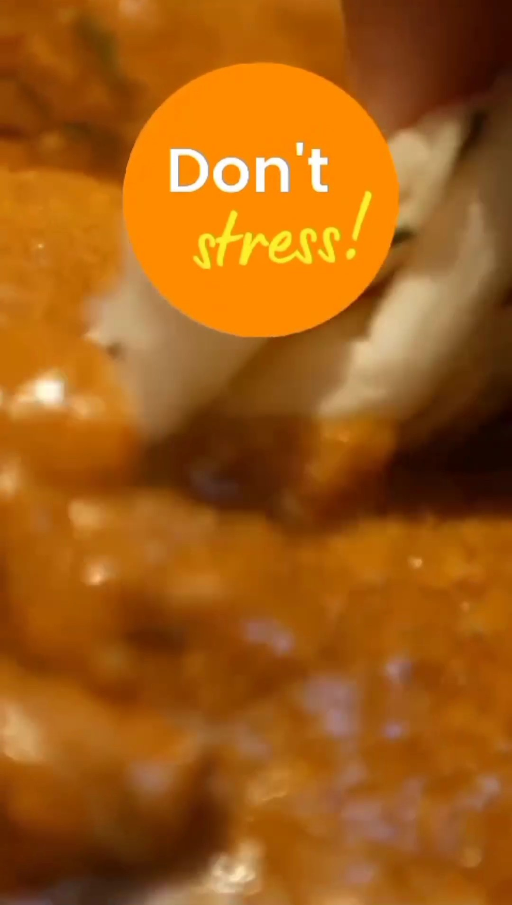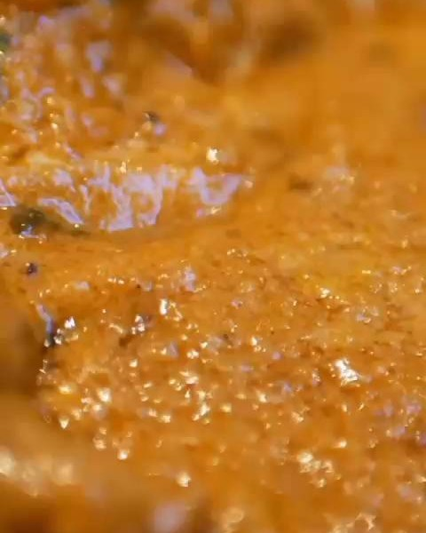

Watch on Instagram Lite [Log in](https://www.instagram.com/accounts/login/?next=%2Freel%2FCyngwpahWPc%2F&source=logged_out_video_overlay)



[202 likes](https://www.instagram.com/p/CyngwpahWPc/liked_by/)



**[Log in](https://www.instagram.com/accounts/login/?next=%2F&source=mobile_nav) Open App**

[ﬁve_spots_eatery](https://www.instagram.com/five_spots_eatery/) • Follow

[tara_19_05](https://www.instagram.com/tara_19_05/) ❤❤

[7 DAYS AGO](https://www.instagram.com/)



[ந ம ெபர ப](https://www.instagram.com/explore/locations/100371274827281/)

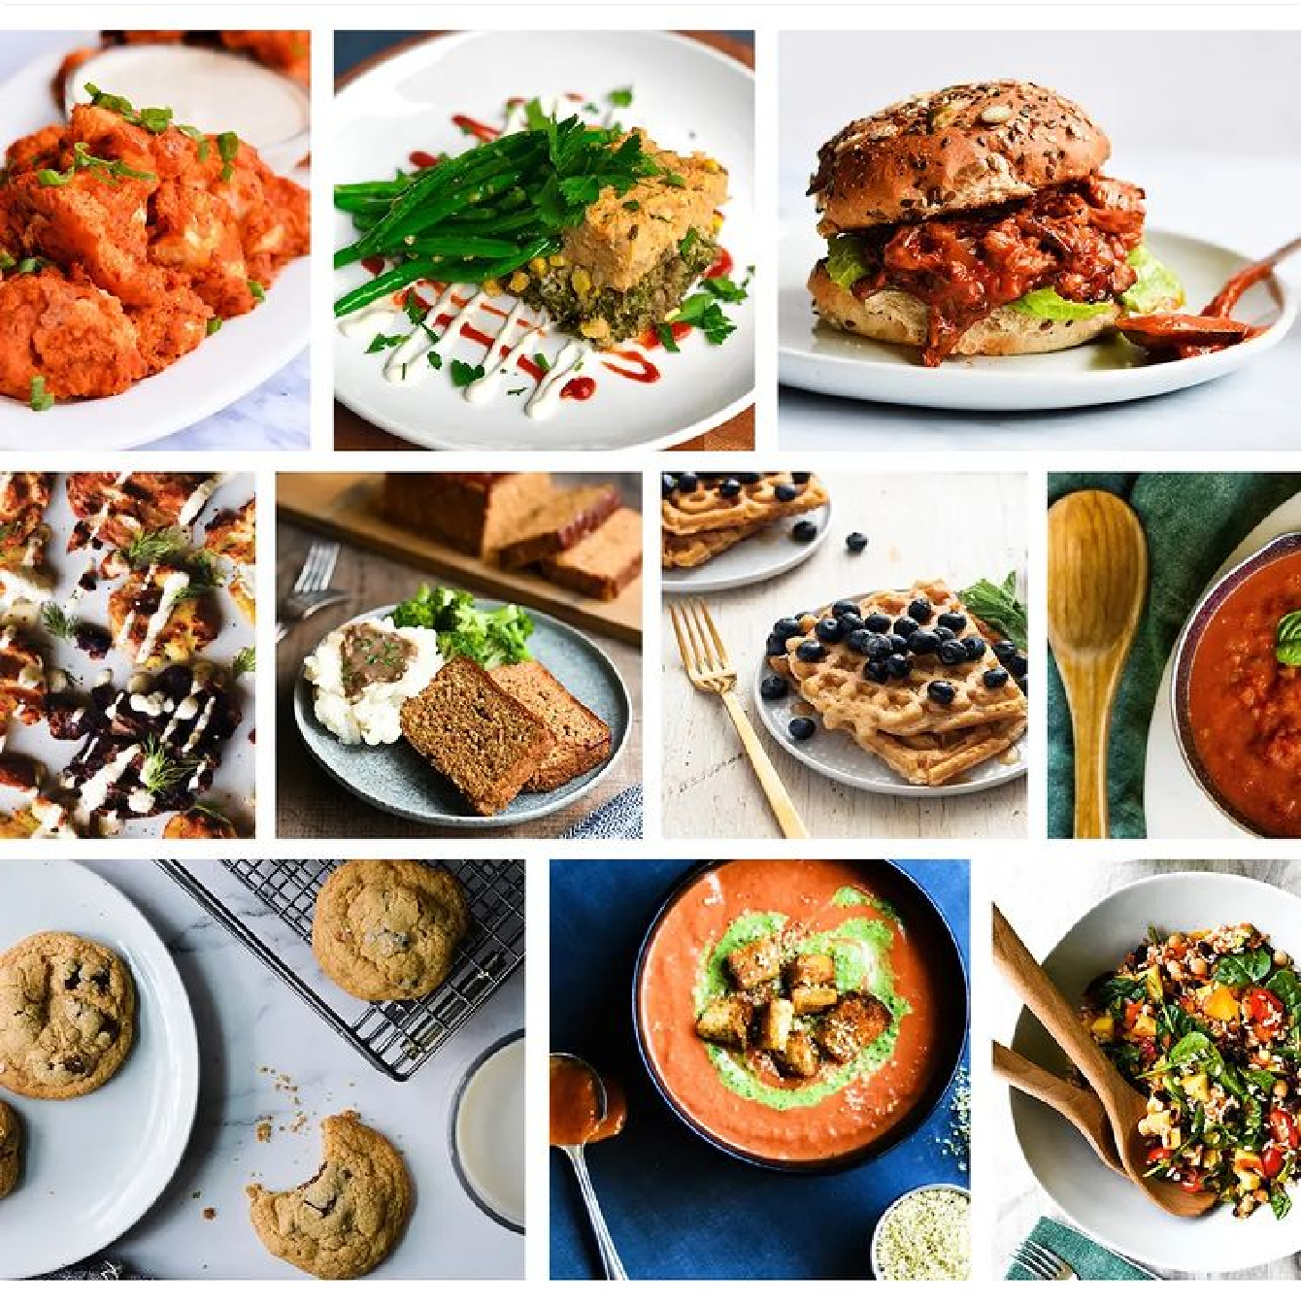

[31 likes](https://www.instagram.com/p/CynQSorhwoC/liked_by/)

[View 1 comment](https://www.instagram.com/p/CynQSorhwoC/comments/?enable_persistent_cta=false)

[20 OCTOBER](https://www.instagram.com/p/CynQSorhwoC/)

[ﬁve_spots_eatery](https://www.instagram.com/five_spots_eatery/) • Follow



[Log in](https://www.instagram.com/accounts/login/?next=%2F&source=mobile_nav) Open App

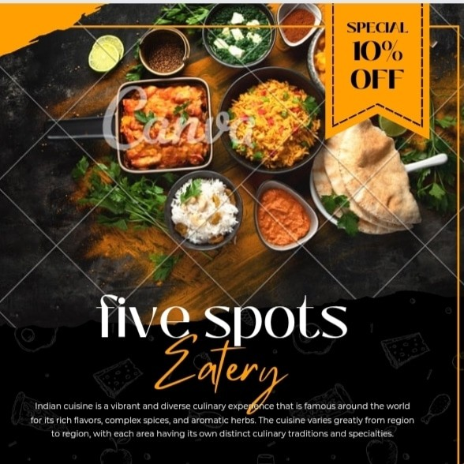



[105 likes](https://www.instagram.com/p/CyiIY6EB7fh/liked_by/)

[View 1 comment](https://www.instagram.com/p/CyiIY6EB7fh/comments/?enable_persistent_cta=false)

[18 OCTOBER](https://www.instagram.com/p/CyiIY6EB7fh/)

 Hashtag trends

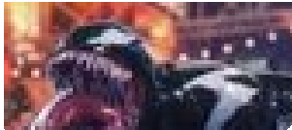

**[Log in](https://www.instagram.com/accounts/login/?next=%2F&source=mobile_nav) [Open A](https://www.instagram.com/explore/tags/1989taylorsversion/)pp**

**[#spiderman2](https://www.instagram.com/explore/tags/spiderman2/)**

**[#theamazingdigitalcir…](https://www.instagram.com/explore/tags/theamazingdigitalcircus/)**

**[#straykids](https://www.instagram.com/explore/tags/straykids/)**

**[#disney100](https://www.instagram.com/explore/tags/disney100/)**

**[#1989t](https://www.instagram.com/explore/tags/1989taylorsversion/)**

[Meta](https://about.meta.com/) [About](https://about.instagram.com/) [Blog](https://about.instagram.com/blog/) [Jobs](https://www.instagram.com/about/jobs/) [Help](https://help.instagram.com/) [API](https://developers.facebook.com/docs/instagram) [Privacy](https://www.instagram.com/legal/privacy/) [Terms](https://www.instagram.com/legal/terms/) [Locations](https://www.instagram.com/explore/locations/) [Instagram Lite](https://www.instagram.com/web/lite/) [Threads](https://www.threads.net/) [Contact uploading and non-users](https://l.instagram.com/?u=https%3A%2F%2Fwww.facebook.com%2Fhelp%2Finstagram%2F261704639352628&e=AT3HCnuVnP8kwc3vx9YanXoBBl57TILLFWt5dFGJWQMoVsEIpH2wP96VbAxtXa8bfn34Yfykq78Xjkcw2l15vknb5PcfoOJrjNM7j9R0KGO_vyW6cRgXeD-0G2Gm2S4poI7pithQr5kSBlNvMOe6oHUekh1ZzzkRLbDfcQ) [Meta Veriﬁed](https://about.meta.com/technologies/meta-verified/)

English (UK) © 2023 Instagram from Meta